# 100 Posts Task 3 vs Task 6

# Task 3 – 24 Users

# Task 6 – 30 Users

### 1k Posts Task 3 vs Task 6

### Task 3 – 30 users

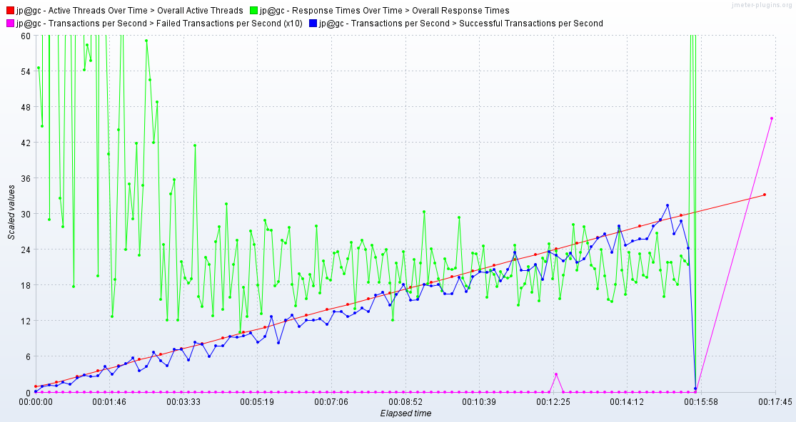  
TASK 6 – 35 USERS

### Task 6 – 100 vs 1000 Posts

|  |  |  |
| --- | --- | --- |
|  | 100 | 1000 |
| Task 3 (random) | 24 Users | 30 Users |
| Task 6 (non-random) | 30 Users | 35 Users |

Analysis

In general, during bigger volume of data usually we expect worse result in terms of capacity. Anyway observing charts we can see saturation point is actually not noticeable – simply application got crush of nowhere – what can point there is simply bug in application that may cause stack over flow exception (infinite loop) or it can be dead lock as well. Unfortunately I didn’t document it but from task manager I’ve noticed IIS CPU usage shoot from 10 % to 100% what cause an issue. As we can see we got better results for volume 1k what can suggest scenario that triggers application crash has simply lower probability. It can be for example opening the same post in parallel for 1k volume it is less possible or simply accessing data about the same post. For example we can notice in task 3 open calendar scenario is has bigger probability and I’ve prepared all post within one month what may cause an issue when it is opened in the same time as then we ask for almost post in database. Bigger probability as well has there Open Contact form but anyway Open contact form bring static date so I wouldn’t expect bug there. Same with opening defined date but it simply ask for 10 posts and search by name search by random name what usually does not bring any results.

|  |  |  |
| --- | --- | --- |
| Task 3 - Probablity | | |
| Open Home Page | 16.66666667 |  |
| Open Random Page | 16.66666667 |
| Open Defined Date | 16.66666667 |
| Search By Name | 16.66666667 |
| Open Large Calendar | 16.66666667 |
| Open Contact | 16.66666667 |
|  |  |
| Open Random Page | 0.5 | 25 |
| Open Post | 0.5 | 12.5 |
| First Or Random | 0.5 | 6.25 |
| Comment | 0.5 | 6.25 |

|  |  |  |
| --- | --- | --- |
| Task 6 - Probablity | | |
| Open Home Page | 15 |  |
| Open Random Page | 10 |
| Open Defined Date | 30 |
| Search By Name | 30 |
| Open Large Calendar | 10 |
| Open Contact | 5 |
|  |  |
| Open Random Page | 0.5 | 27.5 |
| Open Post | 0.8 | 22 |
| First Or Random | 0.65 | 14.3 |
| Comment | 0.2 | 4.4 |